Vision and Scope Document

for

APPLIANCES RETAILER MANAGEMENT

**Version 1.0 approved**

**Prepared by Duc Tho Tran – Hoan Thien Nguyen**

**Group 6**

**19-09-2018**

**Table of Contents**

1. **Business Requirements** **3**
   1. Background 3
   2. Business Opportunity 3
   3. Business Objectives 3
   4. Success Metrics 3
   5. Vision Statement 3
   6. Business Risks 4
   7. Business Assumptions and Dependencies 4
2. **Scope and Limitations** **4**
   1. Major Features 4
   2. Scope of Initial Release 5
   3. Scope of Subsequent Releases 5
   4. Limitations and Exclusions 6
3. **Business Context** **6**
   1. Stakeholder Profiles 6
   2. Project Priorities 7
   3. Deployment Considerations 7

**Revision History**

|  |  |  |  |
| --- | --- | --- | --- |
| **Name** | **Date** | **Reason For Changes** | **Version** |
|  |  |  |  |
|  |  |  |  |

# Business Requirements

## Background

Current system in the Nguyen Kim company is now manually managed even there are many branches. Number of employees presently spend more than 30 minutes each worksheet just for checking quantity remains in warehouse at the end of worksheet. Sale employees spend about 2 minutes for each time when they sell a product to record sales and customer’s information. According to statistics, there are more than 200 orders per day per store. It means that sale employees must take more than 400 minutes for sale task; however, those amount of time is not effective and hardly to avoid mistakes. With instability when operating the work checking warehouse 2 times per day and recording sales, accountant will not able to calculate exactlyfinance and economy of company. With manual warehouse management, an item can be redundant in one store while it can be insufficient in others.

## Business Opportunity

Realizing the situation, Nguyen Kim’s CEO requested a centralized system to manage all stores remotely, consistently, and efficiently. Employees will save a lot of time writing reports, checking warehouse, thus they will have more time to serve customers’ needs. Managers will be able to know inventory instantly, thus adjust the number of items to buy, the marketing strategy, etc. Items can also be moved from one place to another where it is well-sold and insufficient. Such a system will also grant managers the ability to manage staffs, customers and revenue easily. Management costs will reduce significantly, leading to company’s profit growth.

## Business Objectives

* BO-1: Reduce inventory number to 10% (past 20%) within 3 months following initial release.
* BO-2: Increase staffs’ efficient time at work by 200 minutes per day within 3 months following initial release.
* BO-3: Reduce operating costs by at least 20% within 6 months after initial release.

## Success Metrics

* SM-1: The frequency of customer interaction increased by at least 20% in 3 months following initial release.
* SM-2: Sales growth rate increased by at least 5% within 2 quarters following initial release.

## Vision Statement

For staffs who need an easy way to record transactions’ information, the Appliances Retailer Manager is a system that will provide an approach to record the information in less than a minute. The system will store customers’ information, update products’ quantity being sold, save and print bill. The system will save more than 2 hours for each staff everyday, which means they have more time to serve more customer. For managers who need approach to control all branches, the system will provide a single point of access to produce statistical data. The system will monthly generate statistical data on revenue of each branch as well as on sale of each item. Unlike the current manual inventory making process, our product will produce a detailed inventory base on sale data, as well as update the list when items are moved in or out the warehouse. Our system also suggest moving items from one place to another where it’s well-sold. With such a system, Nguyen Kim will reduce management cost significantly, increase revenue and expand its scale.

## Business Risks

* RI-1: Difficult to change the working habits of employees - especially sales staff and warehouse staff. It is not easy to guide employees to strictly abide by the new system. (Probability = 0.2; Impact = 6; Solution: Divide tasks into multiple stages)
* RI-2: The challenge is to synchronize data between repositories - the job requires precision. (Probability = 0.3; Impact = 2)
* RI-3: Scaling up system is the problem about the human resource management; it is difficult to verify when affiliates intentionally report false information. (Probability = 0.1; Impact = 6)

## Business Assumptions and Dependencies

* AS-1: The company has enough the means and equipment to operate the system.
* AS-2: Increasing employee efficiency at work will result in increasing the frequency of customer interaction.
* AS-3: Each store has only one warehouse.

# Scope and Limitations

## Major Features

* FE-1: Recording transactions’ information when completing a transaction.
* FE-2: Reviewing executed transactions - including related information: customers’ information, payment, product and branch.
* FE-3: Manage the quantity of products from a repository - including additions, removals, reports operations.
* FE-4: Applying promotional,discount policy,.
* FE-5: Producing statistics on product sales of each store, or the whole system for a certain period.
* FE-6: Producing statistics on revenue at store scale as well as system scale.

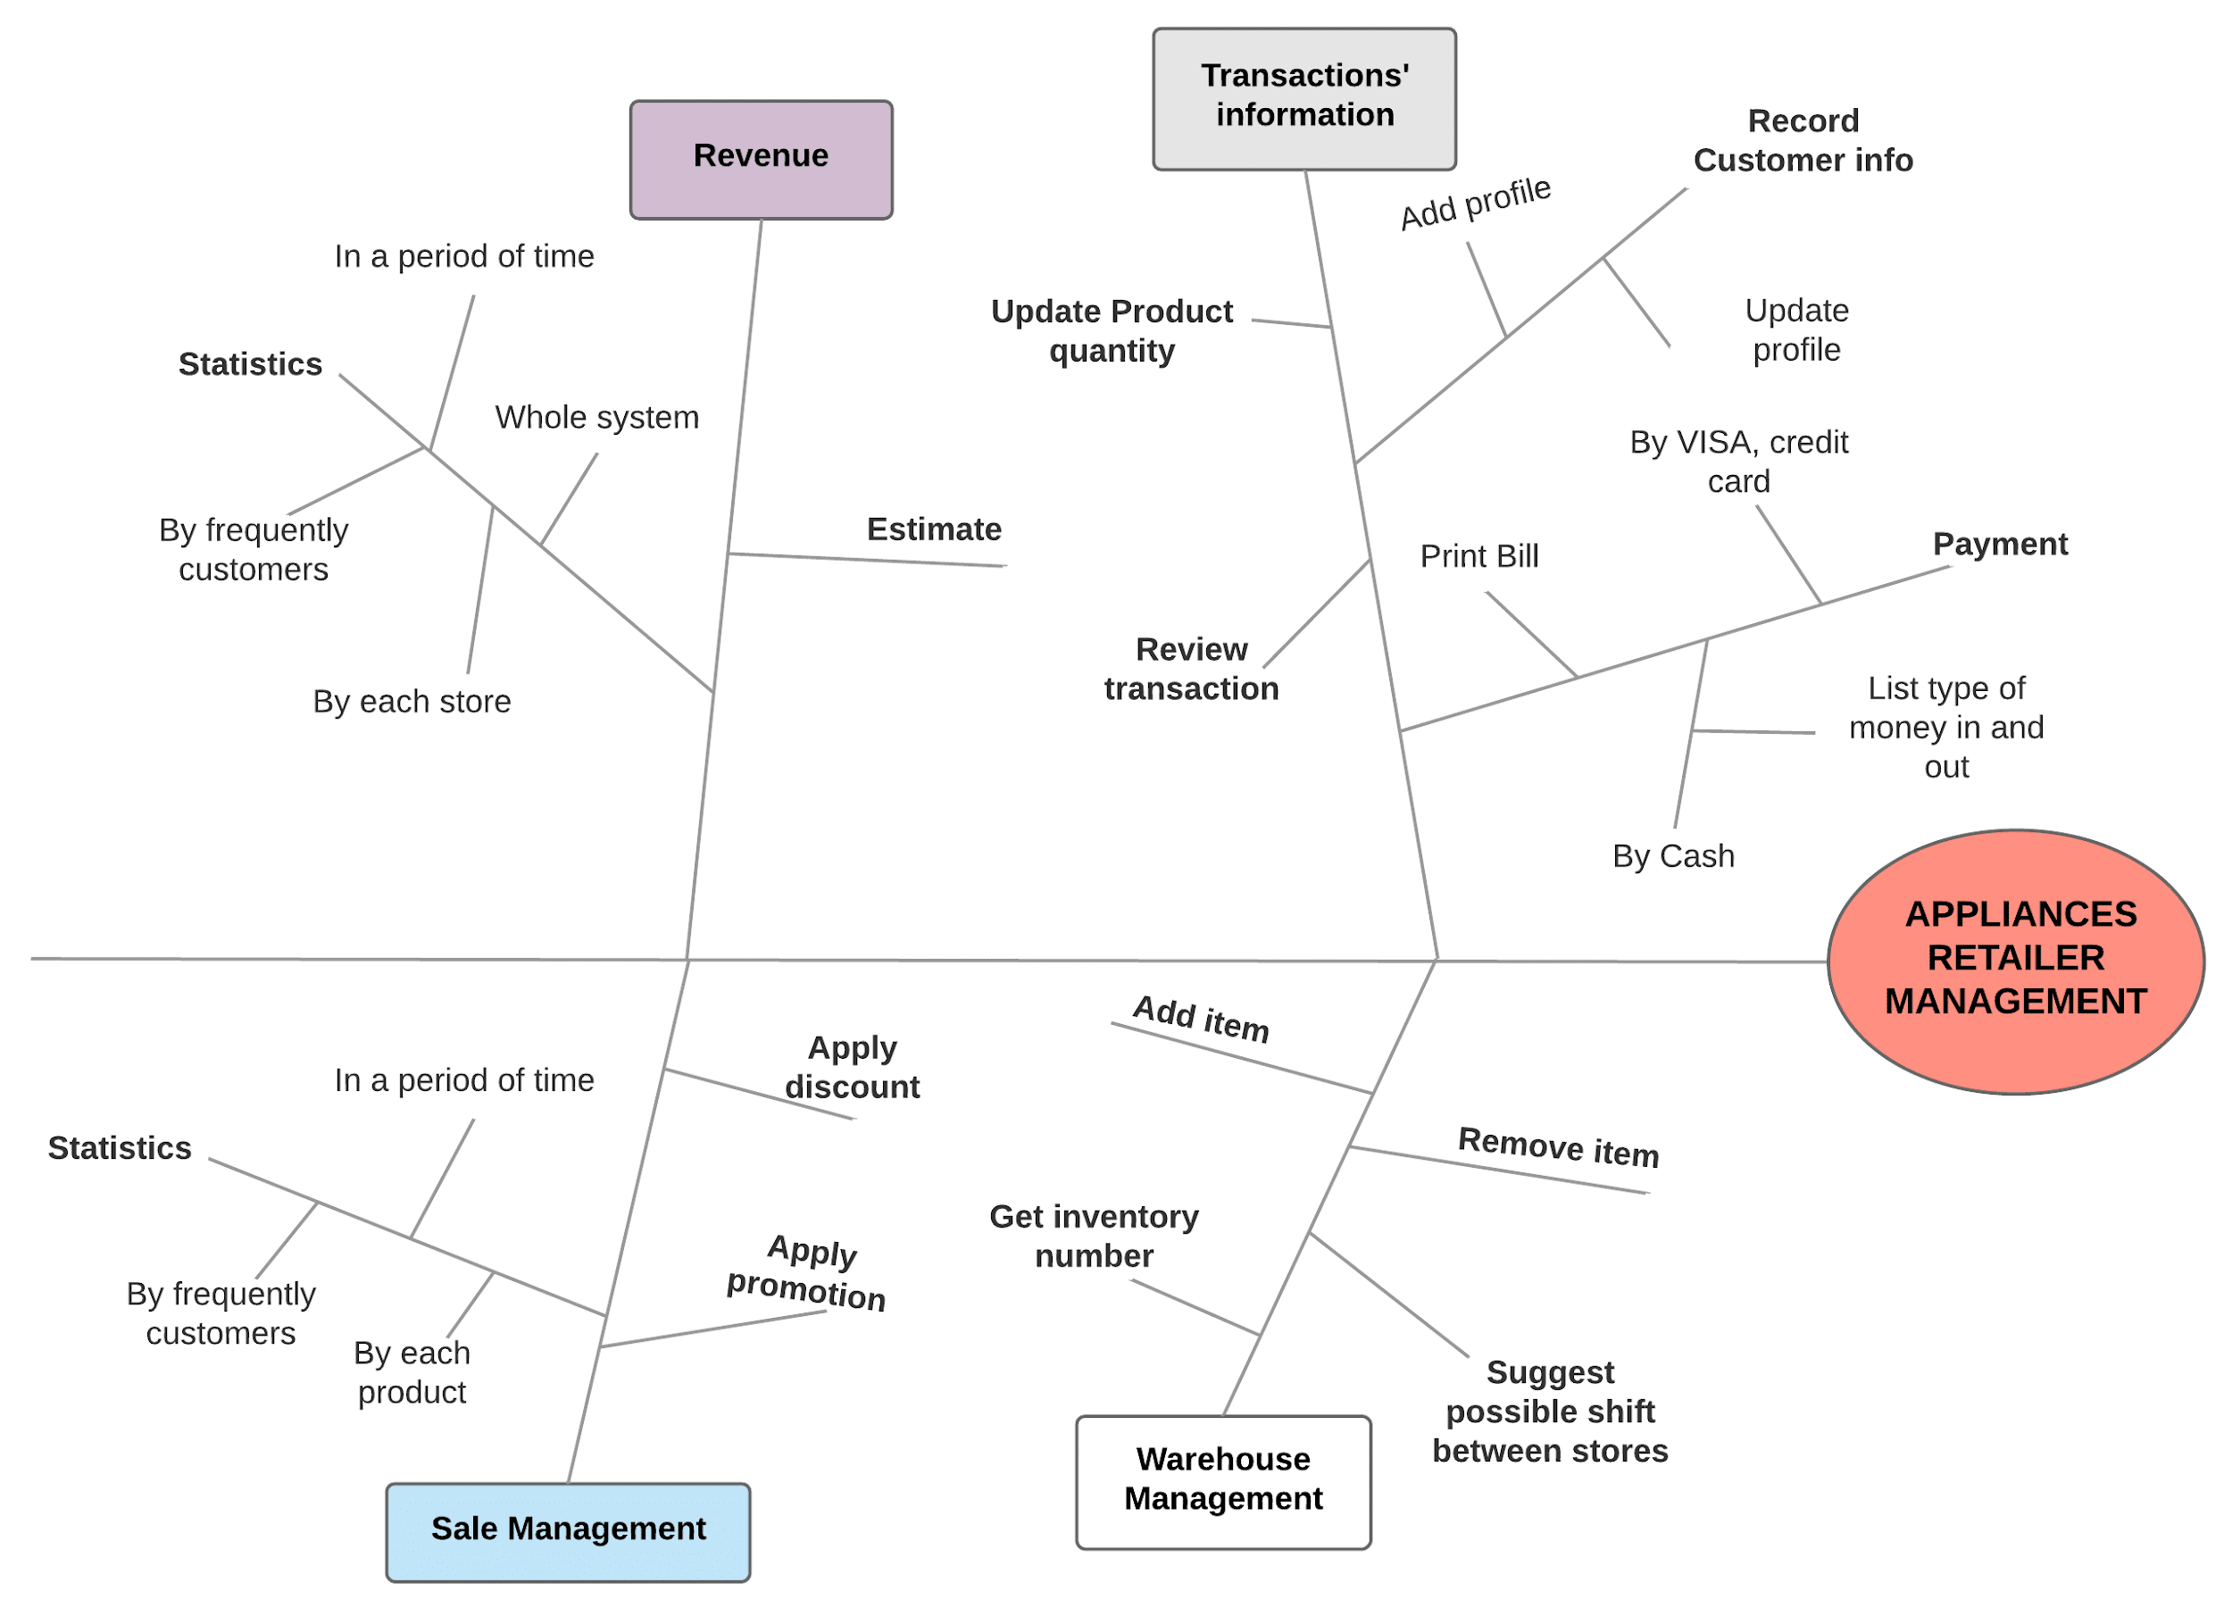

**Figure 1.** Partial feature tree for the Appliances Retailer Management

## Scope of Initial Releases

|  |  |  |
| --- | --- | --- |
| Feature | Release 1.0 | Release 2.0 |
| FE-1 | Fully implemented |  |
| FE-2 | Fully implemented |  |
| FE-3 | Update data as items are moved in or out | Suggest possible shift between warehouses |
| FE-4 | Not implemented | Implemented |
| FE-5 | Not implemented | Implemented |
| FE-6 | Producing statistics on revenue for each store | Producing statistics on revenue for the whole system |

## Limitations and Exclusions

* LI-1: Software only allows access from employees whose accounts are compatible with the system.//re-considered
* LI-2: Only accept access from computers, laptops and smartphones.
* EX-1: Statistical functions are not available in the first operation as well as no transaction.

# Business Context

## Stakeholder Profiles

|  |  |  |  |  |
| --- | --- | --- | --- | --- |
| **Stakeholder** | **Major Value** | **Attitudes** | **Major Interests** | **Constraints** |
| Salesman | Record transactions’ information | Highly receptive | Make the the business process faster  Job preservation | Easy to use |
| Warehouse management | Reduce manual counting significantly | Hesitate | No need to stay late in order to check warehouse | None |
| Sale & Marketing Department | Apply promotion, discount | Highly expectant | Produce statistical data automatedly | None |
| Executives | Decrease management cost | Hopeful | Increase | Maximum budget is 100 million VND. |

## Project Priorities

|  |  |  |  |
| --- | --- | --- | --- |
| **Dimension** | **Constraint** | **Driver** | **Degree of freedom** |
| **Schedule** |  | Version 1.0 release in 3/1/2019 |  |
| **Features** | All features scheduled for release 1.0 must be fully operational |  |  |
| **Quality** | 95% of user acceptance tests must pass; all security tests must pass |  |  |
| **Staff** |  | maximum team size is 1 PM, 1 BA, 10 developers + 3 testers |  |
| **Cost** |  |  | Funds increased by up to 10% compared to expected |

## Deployment Considerations

Ensure to synchronize data between all warehouses before the system is deployed. The bandwidth at stores must be at least 2.0 Mbps. An instruction video’s also needed.